FOR OFFICERS IN BPS 17 & 18 CONFIDENTIAL

GOVERNMENT OF PAKISTAN

Ministry /Division/ Service/Group

Department/Office

PERFORMANCE EVALUATION REPORT
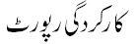

FOR THE PERIOD 20 TO 20

PART I
(TO BE FILLED IN BY THE OFFICER REPORTED UPON)

- Name (in block letters)
- Personnel number
- Date of birth
4. Date of entry in service
5. Post held during the period (with BPS)
- Academic qualifications
- Knowledge of languages (Please indicate proficiency in speaking (S), reading (R) and writing (W)

8. Training received during the evaluation period

Name of course attended | Duration with dates | Name of institution and country
9. Period served
(i) In present post (ii) Under the reporting officer

PART II
(TO BE FILLED IN BY THE OFFICER REPORTED UPON)
1. Job description
2. Brief account of performance on the job during the period supported by statistical data
where possible. Targets given and actual performance against such targets should be
highlighted. Reasons fro shortfall, if any, may also be stated.

PART III -
(EVALUATION BY THE REPORTING OFFICER)
The rating in Part III should be recorded by initialing the appropriate box.
The ratings denoted by alphabets are as follows:
'A' Very Good, 'B' Good, 'C' Average, 'D' Below Average
For uniform interpretation of qualities, two extreme shades are mentioned
against each quality.

 |  | A | B | C | D
1. | Intelligence  Exceptionally bright; excellent comprehension |  |  |  |  | Dull; slow
 |  | A | B | C | D
2. | Confidence and will power  Exceptionally confident and resolute |  |  |  |  | Uncertain; hesitant
3. | Acceptance of responsibility  Always prepared to take on responsibility even in difficult cases. |  |  |  |  | Reluctant to take on responsibility; will avoid it whenever possible.
4. | Reliability under pressure  Calm and exceptionally reliable at all times - |  |  |  |  | Confused and easily flustered even under normal pressure.
5. | Financial responsibility  Exercises due care and discipline |  |  |  |  | Irresponsible
6. | Relations with -  (i) Superiors -  Cooperative and trusted |  |  |  |  | Un-cooperative
 | ii) Colleagues  Works well in a team |  |  |  |  | Difficult colleague
 | iii) Subordinates -  Courteous and effective;  encouraging |  |  |  |  | Discourteous and intolerant;
7. | Behavior with public  Courteous and helpful - |  |  |  |  | Arrogant, discourteous and indifferent
8. | Ability to decide routine matters  Logical and decisive - |  |  |  |  | Indecisive;  Vacillating
 |  | A | B | C | D
9. | Knowledge of relevant laws, rules, regulations, instructions and procedures.  Exceptionally well informed,  keeps abreast of latest developments. |  |  |  |  | Ignorant and  Uninformed.

PART IV -
(REPORTING OFFICER'S EVALUATION)
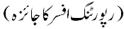

1. Please comment on the officer's performance on the job as given in Part II(2)
with special reference to knowledge of work, quality and quantity of output.
How far was the officer able to achieve targets? Do you agree with what has
been stated in Part II (2)?
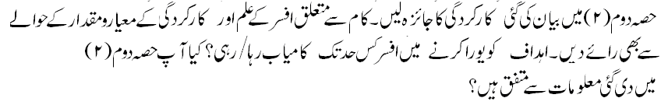

 |  | A | B | C | D
1 | Quality of work  Always produce work of exceptionally high Quality  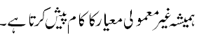 |  |  |  |  | Generally produces work of poor quality.  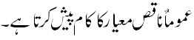
2 | Output of work  Always up-to-date; accumulates no arrears  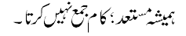 |  |  |  |  | Always behind schedule; very slow disposal.  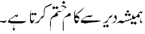
2. Integrity (Morality, uprightness and honesty) -

 |  | A | B | C | D
1. | Integrity  - General  Irreproachable |  |  |  |  | Unscrupulous  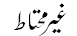
 | - Intellectual  Honest & straightforward |  |  |  |  | Devious; Sycophant

3. Pen picture with focus on the officer's strengths and weaknesses not
covered in Part III (Weakness will not be considered as adverse entries unless
intended to be treated as adverse).
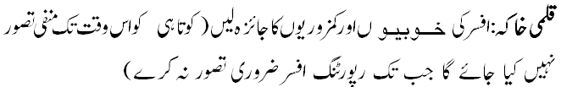

4. Special aptitude
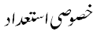

5. Recommendations for future training

6. Overall grading

 |  | Reporting officer | Countersigning officer
(i) | Very Good
(ii) | Good
(iii) | Average
(iv) | Below Average

7. Fitness for promotion

 |  | Reporting officer | Countersigning officer
(i) | Fit for promotion
(ii) | Recently promoted/appointed.  Assessment premature
(iii) | Not yet fit for promotion
(iv) | Unlikely to progress further

Name of the reporting officer Signature
(Capital letters)

Designation Date

PART V
(REMARKS OF THE COUNTERSIGNING OFFICER)
1. How well do you know the officer? If you disagree with the assessment of
the reporting officer, please give reasons

- Evaluation of the quality of assessment made by the reporting officer

Exaggerated |  | Fair |  | Biased

Name of the countersigning officer Signature
(Capital letters)

Designation Date

PART VI
REMARKS OF THE SECOND COUNTERSIGNING OFFICER (IF ANY)

Name Signature

Designation Date

